NOTES:
- dimensions specified in cm,
- cover of bottom reinforcement bars 7 cm
- connect foundations to the lightning conductor according to the industry drawings
- place the prefabricated foundation on a levelled substrate (sand and gravel bed 30 cm thick compacted Id = 0.8)
- in the case of pouring the foundation slab on site, do not make the assembly rod No. 3
- maximum substrate pressure does not exceed 90 kPa
CONCRETE B-25
STEEL A-III
no.
no.
no.
no.
no.
FOUNDATION F-1
scale 1:20
no.
no.
no.
no.
no.
sand and gravel bed 30 cm thick
no.
no.
sand and gravel bed 30 cm thick
no.
no.
no.
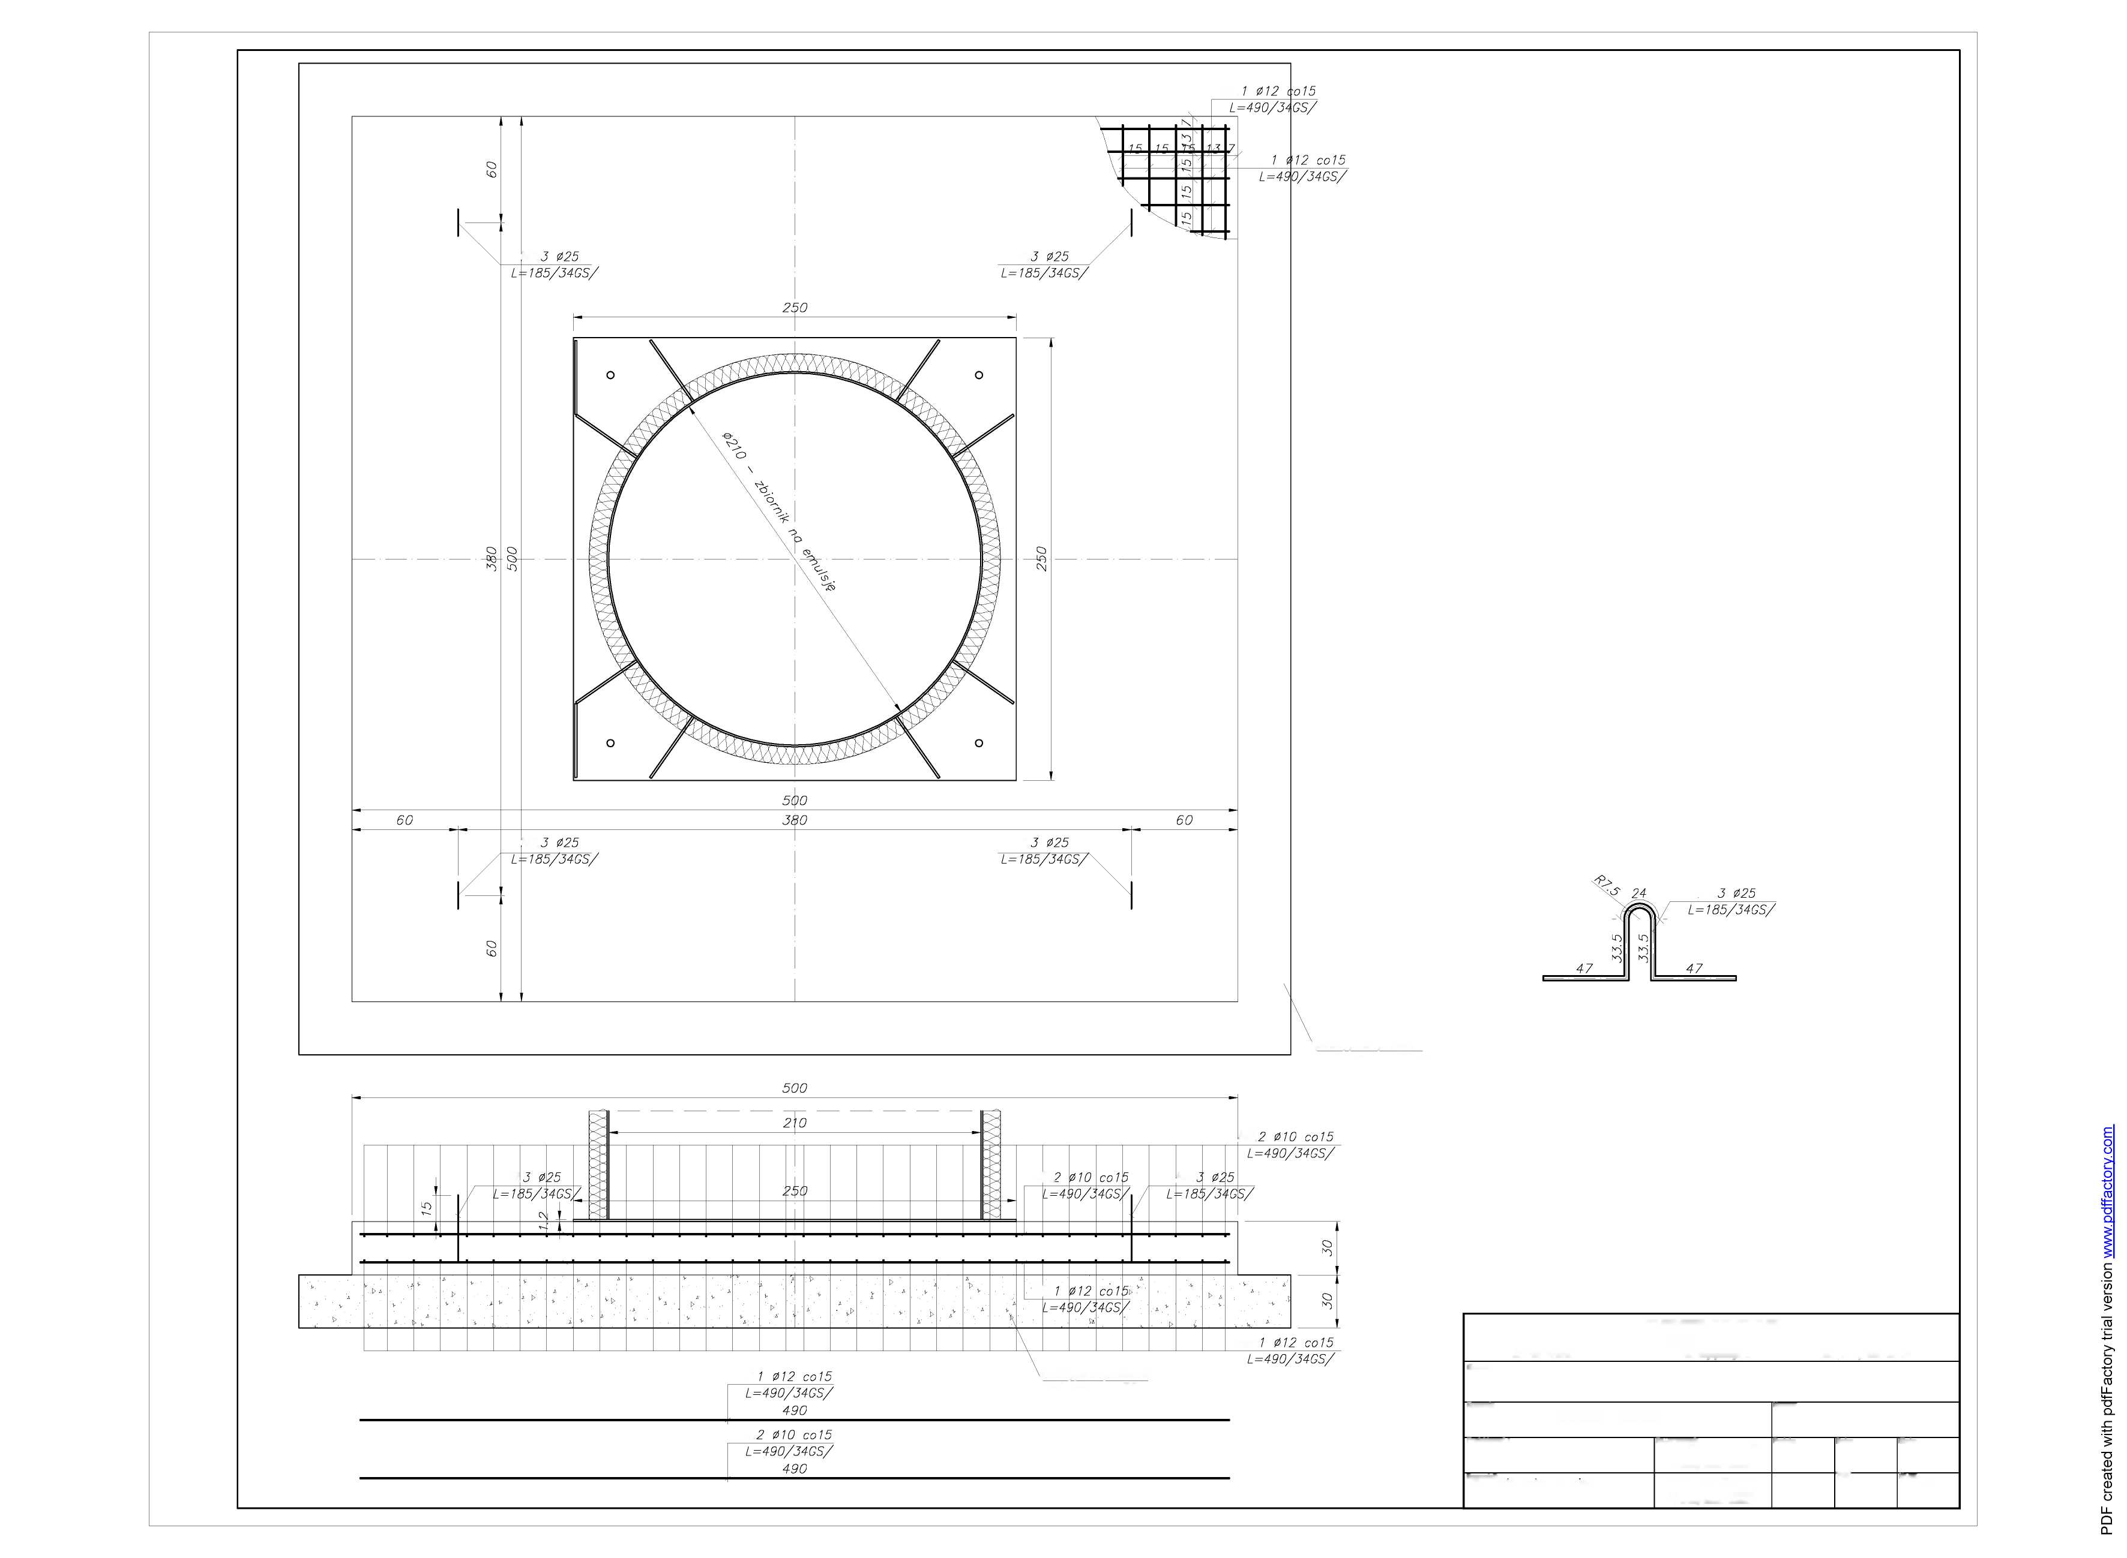

emulsion tank

COMPREHENSIVE DESIGN OFFICE
»UNIPROMAG«
33-100 Tarnów, | ul. Rogoyskiego 2, |  | Phone |  | (0-14) 626-36-54
FACILITY:
ASPHALT EMULSION STORAGE TANK ZE - 20000-30000
Drawing: |  | Industry:
Foundation reinforcement F-1 |  |  | Construction
Designed:  mgr. eng. Rafał Smoleń | No. of qualification:  MAP/0176/P00K/05  authorized for design without limitations in the construction-building industry. | SIGNATURE: |  | Date:  03-2011 |  | SCALE:  1: 20
Checked: .  eng. Władysław Magiera | GT-IV-63/98/77 |  |  | Area |  | Drawing no.  1.
 | authorized for design without limitations in the construction-building industry |  |  |  |  | Drawing no.  1.

